Project Development Phase Sprint - 1

|  |  |
| --- | --- |
| Team ID | PNT2022TMID08113 |
| Project Name | Project - Retail Store Stock Inventory Analytics |

SPRINT-1

* Data Collection
* Data Preparation

# Data Collection:

1. **Download the Dataset**

Dataset link - [https://drive.google.com/file/d/1awFIKJ9LiIdnNHwGLcsqNDbbwshFHR-](https://drive.google.com/file/d/1awFIKJ9LiIdnNHwGLcsqNDbbwshFHR-w/view) [w/view](https://drive.google.com/file/d/1awFIKJ9LiIdnNHwGLcsqNDbbwshFHR-w/view)

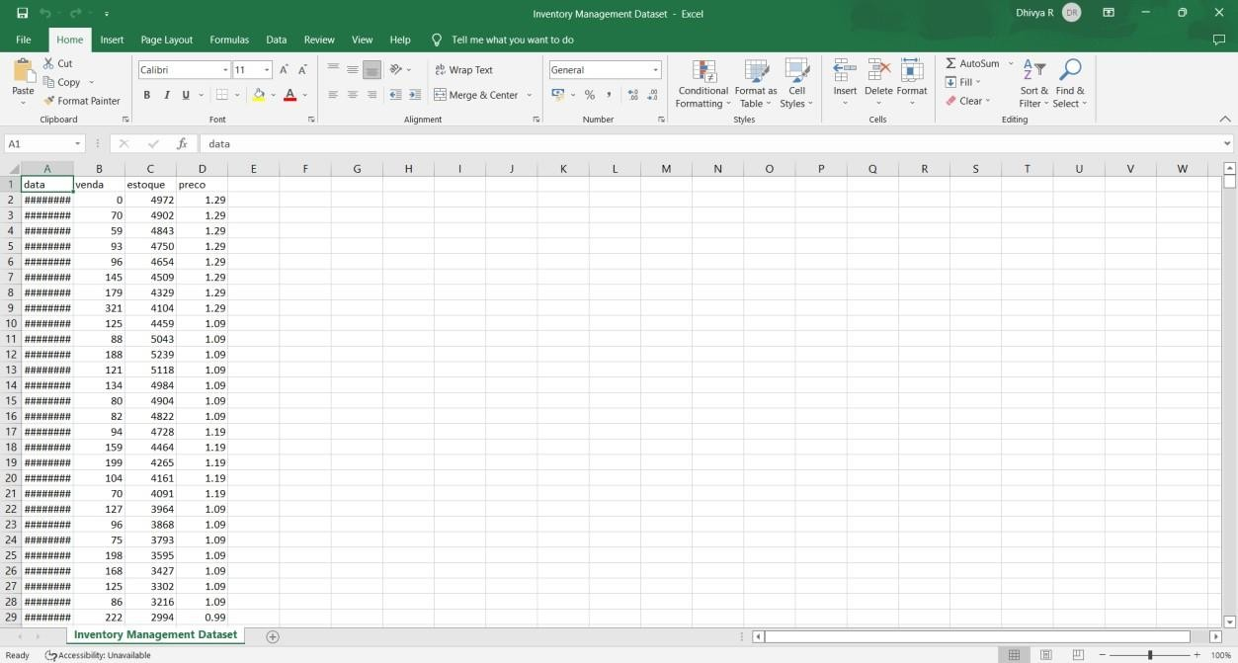

# Load the Dataset

Tool Used: IBM Cognos

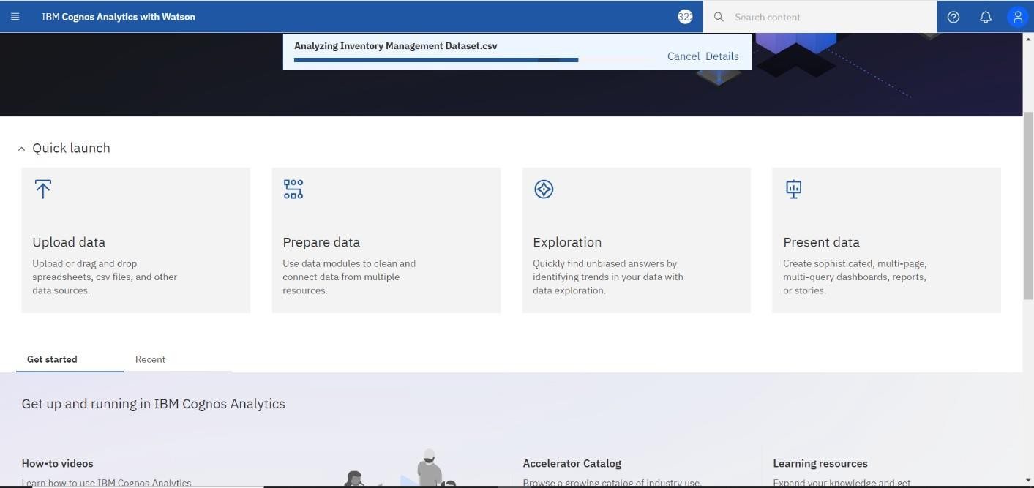

# Data Preparation:

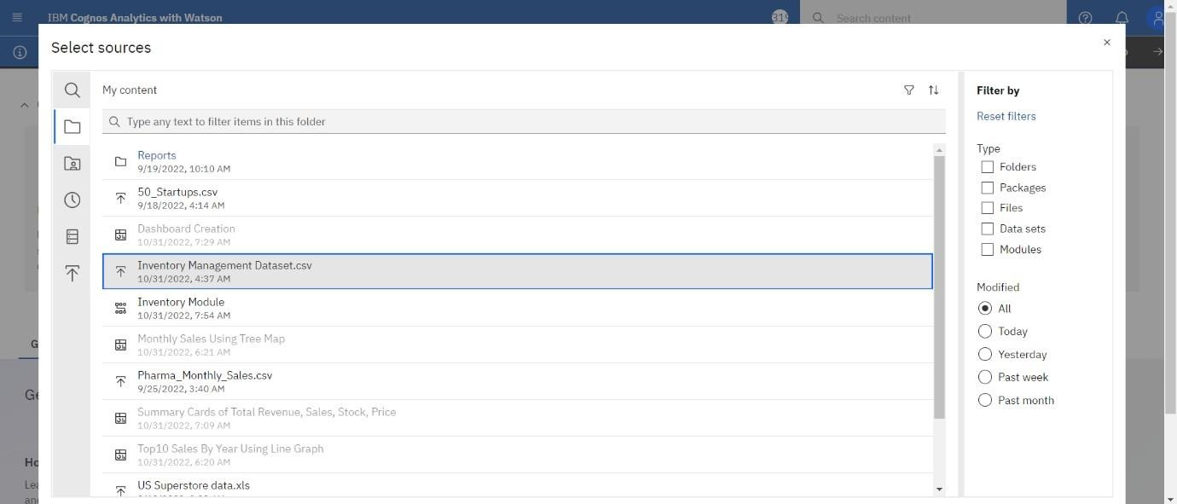

Month Data(M_Data):

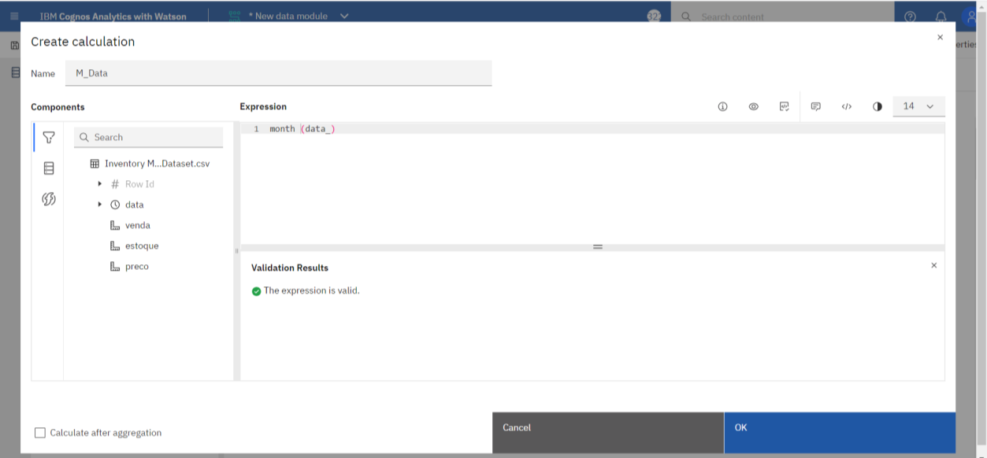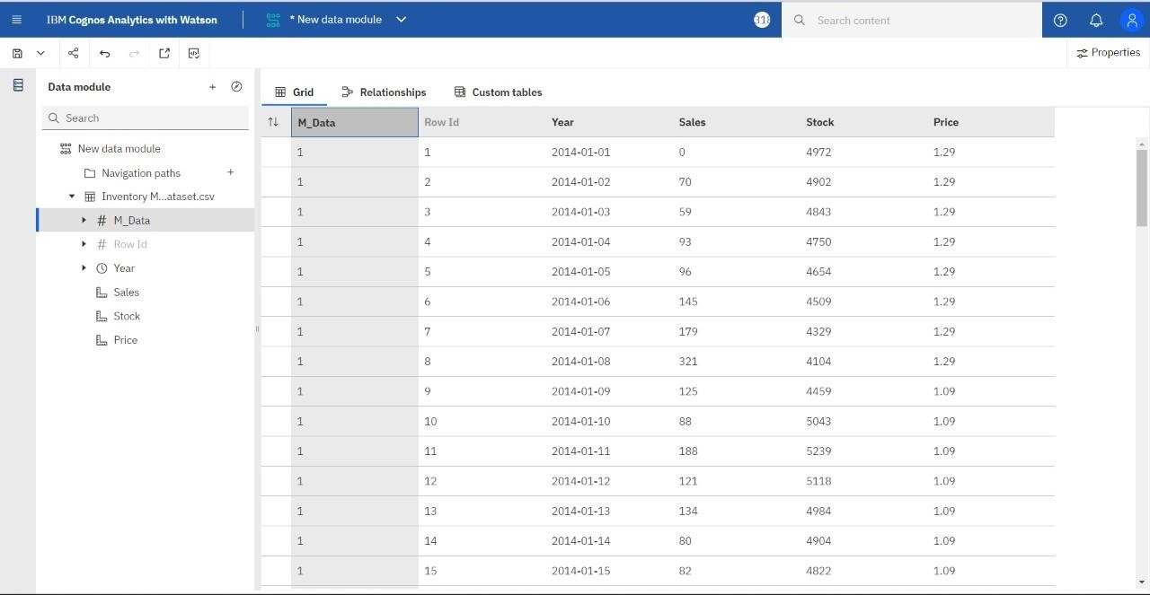

Revenue Data:

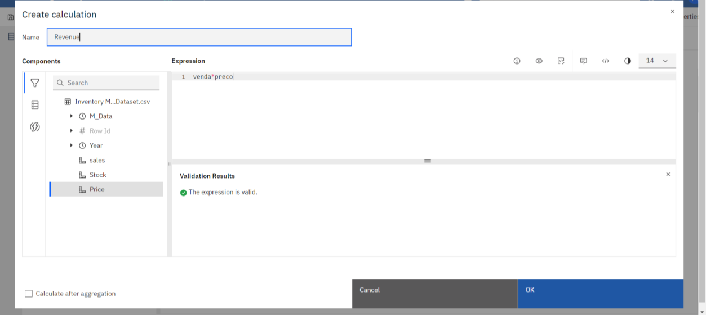

Year Data:

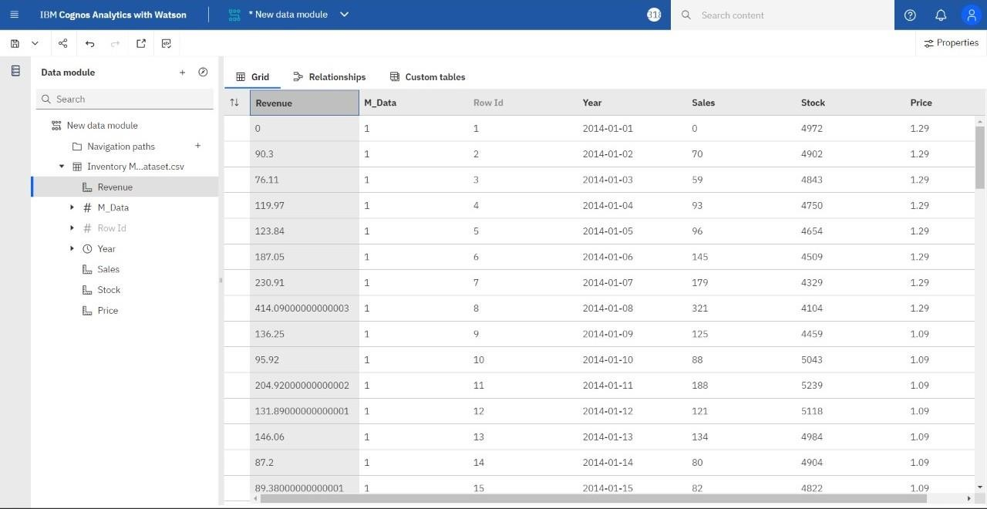Year Data:

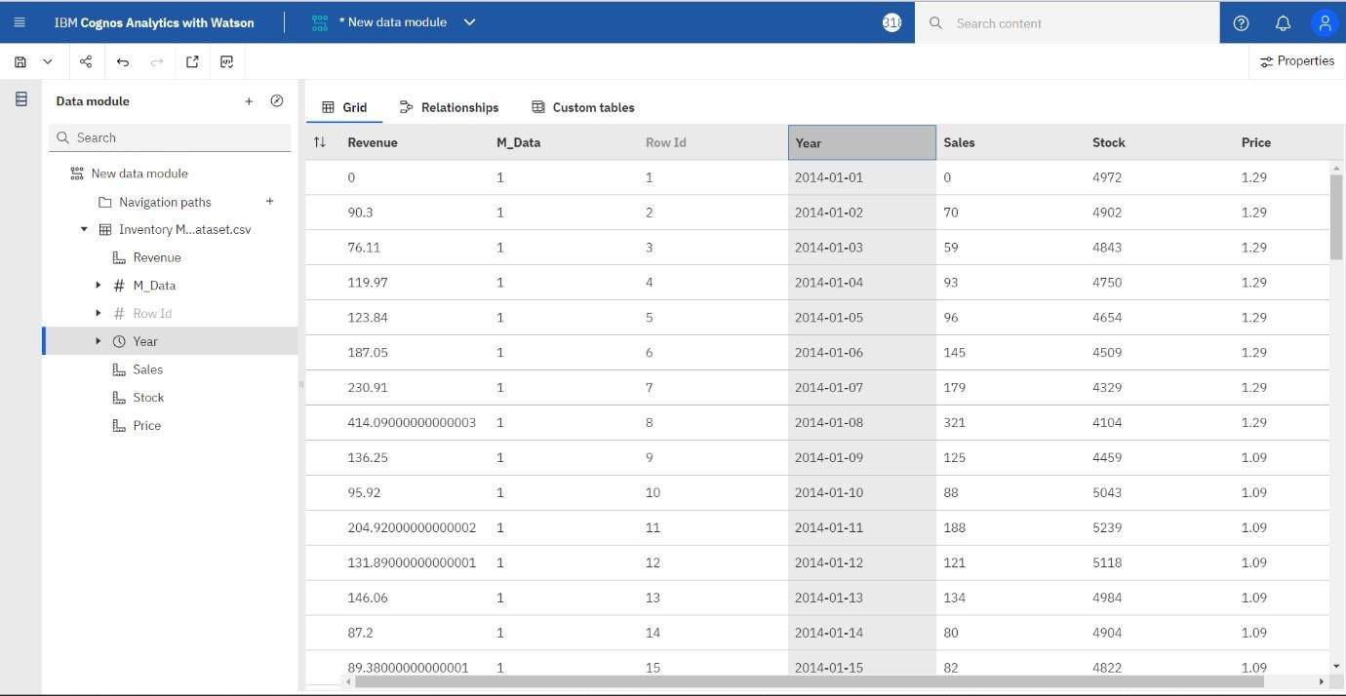

Stock Data:

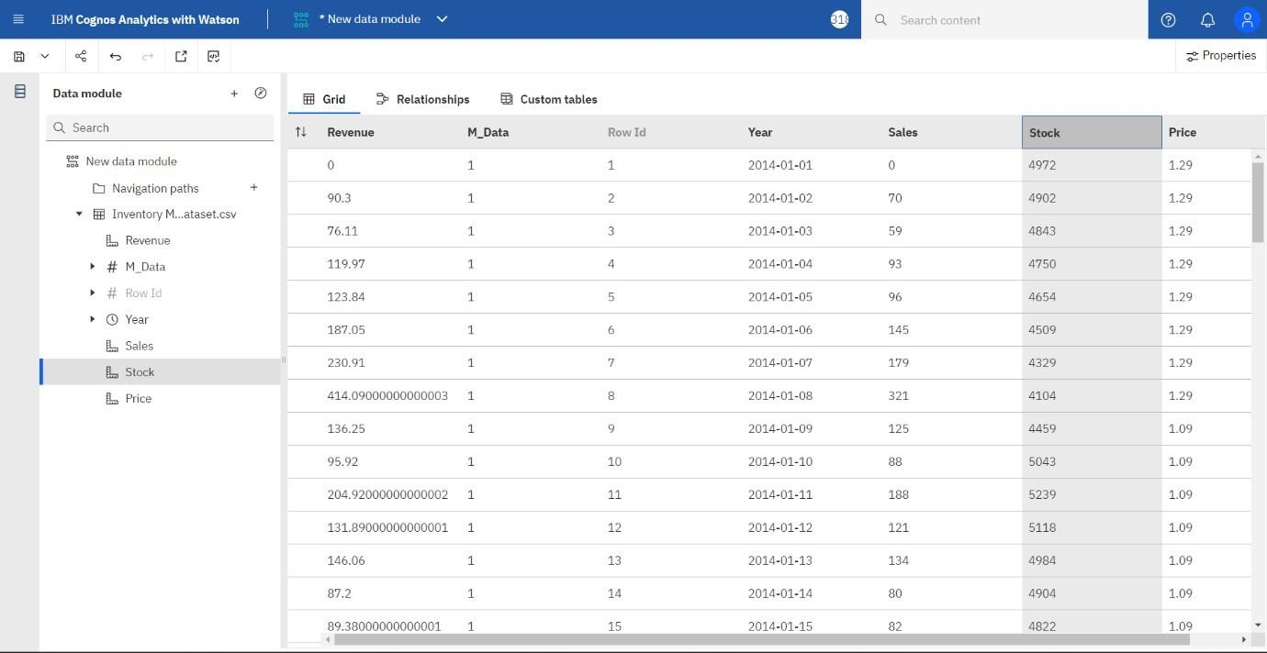

Sales Data:

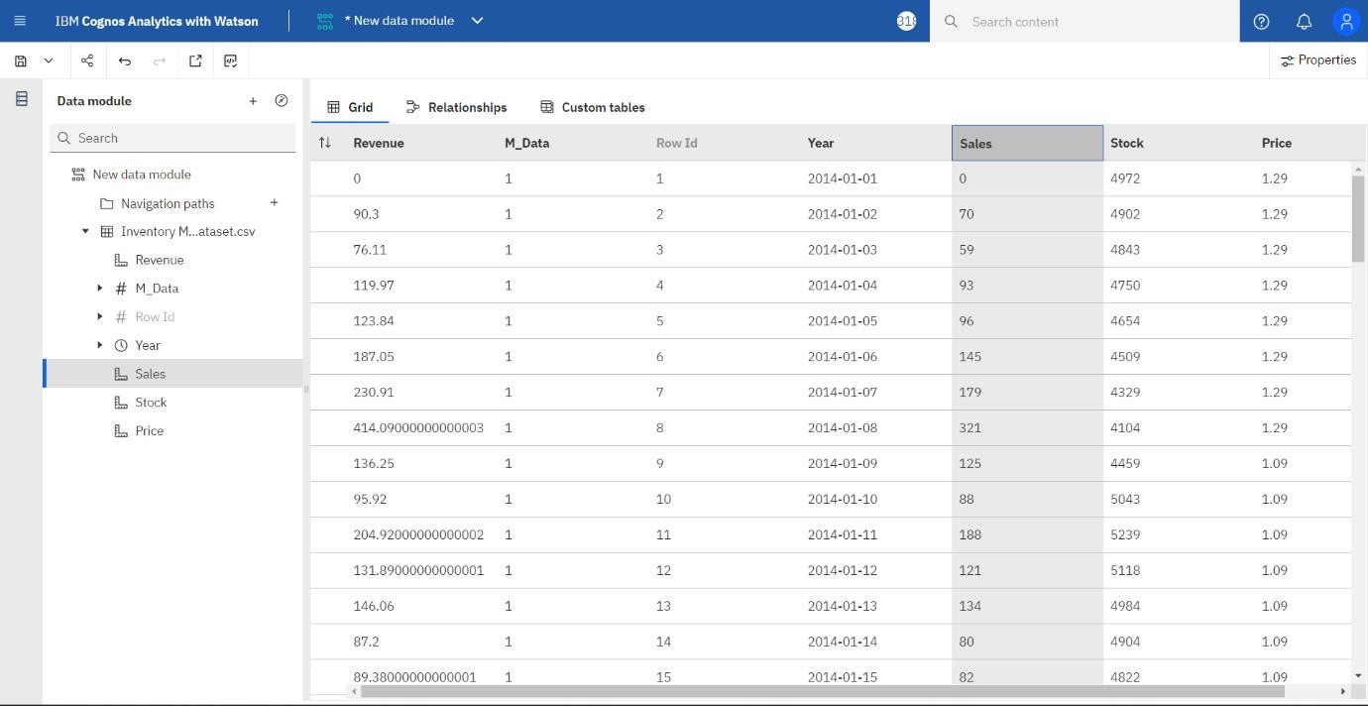

Price Data:

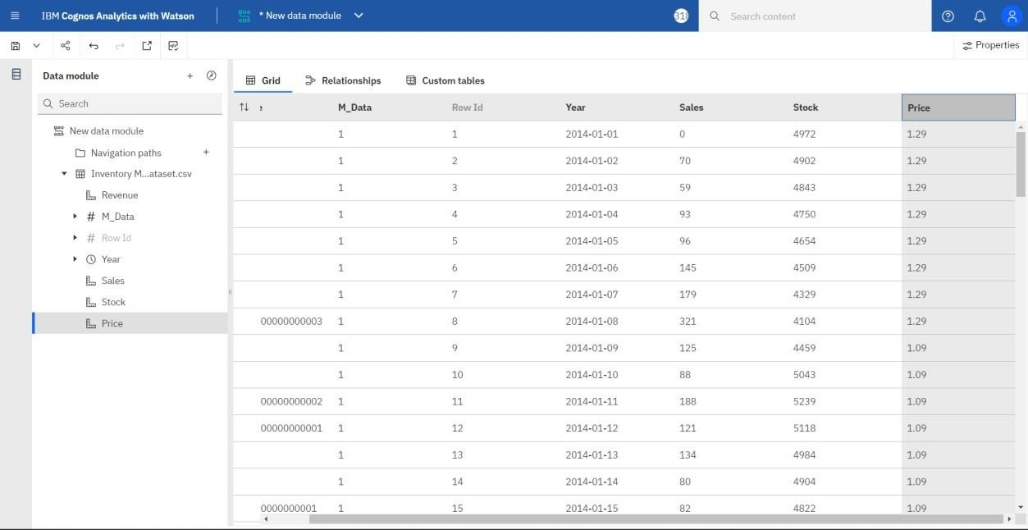

Month Format Data:

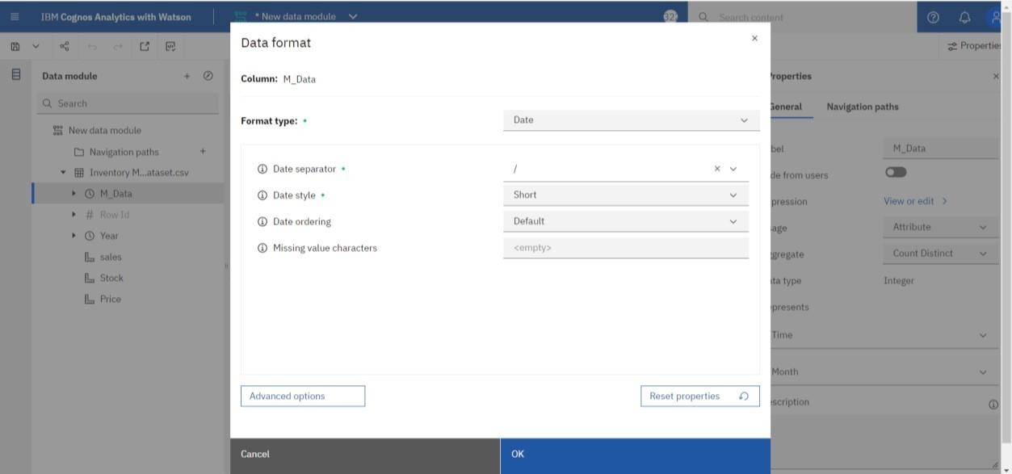

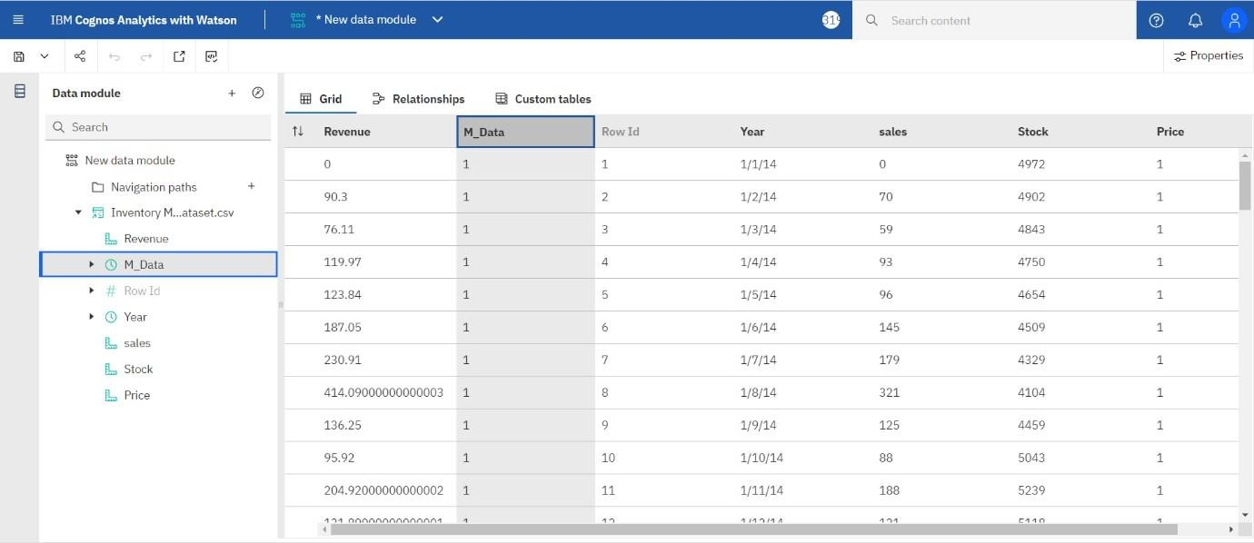

Year Format Data:

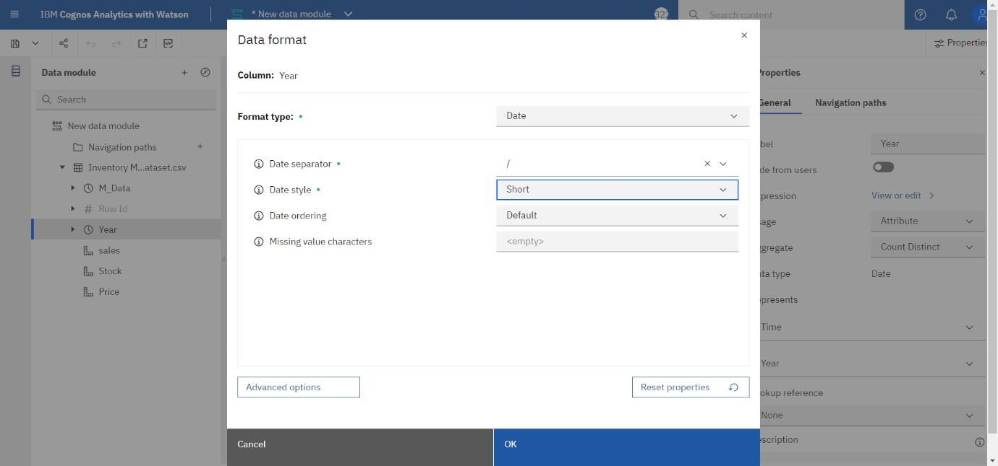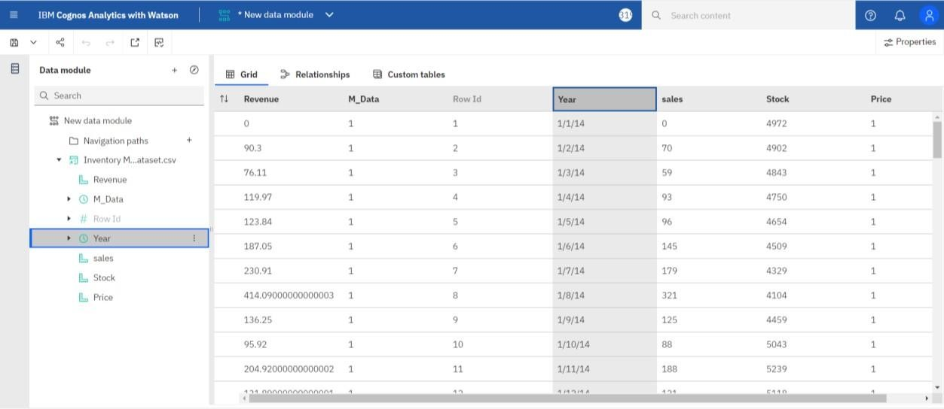

Stock Format Data:

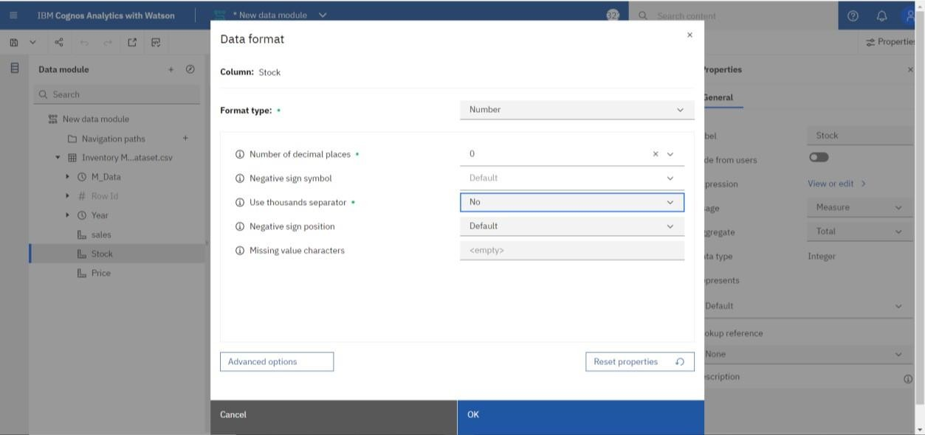

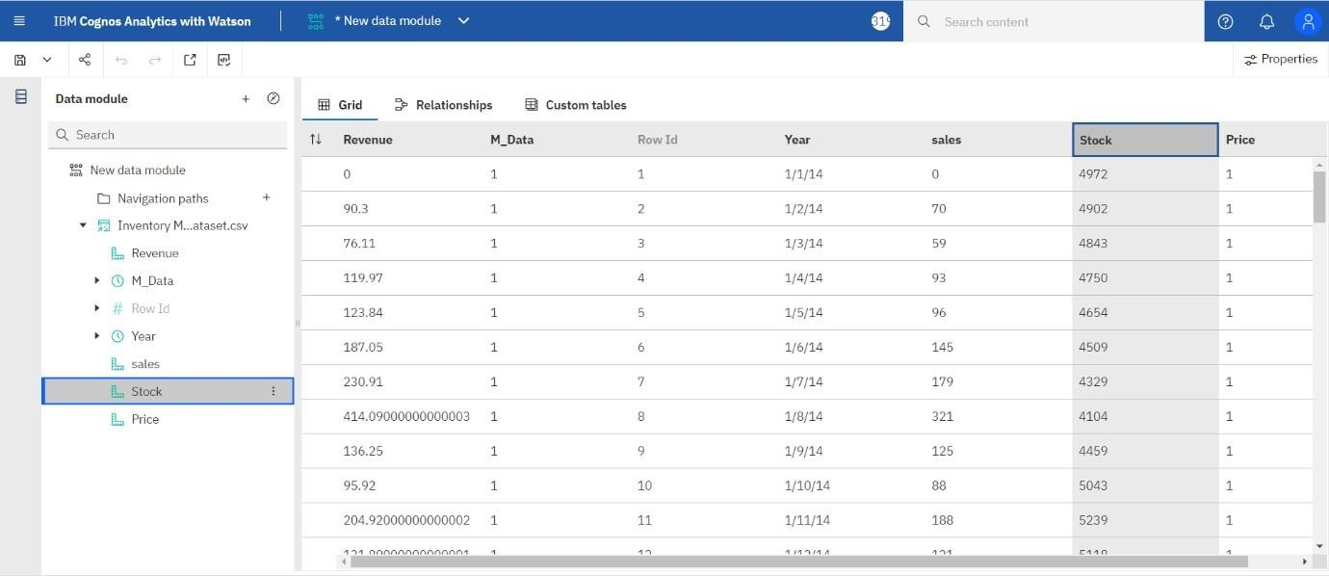

Sales Format Data:

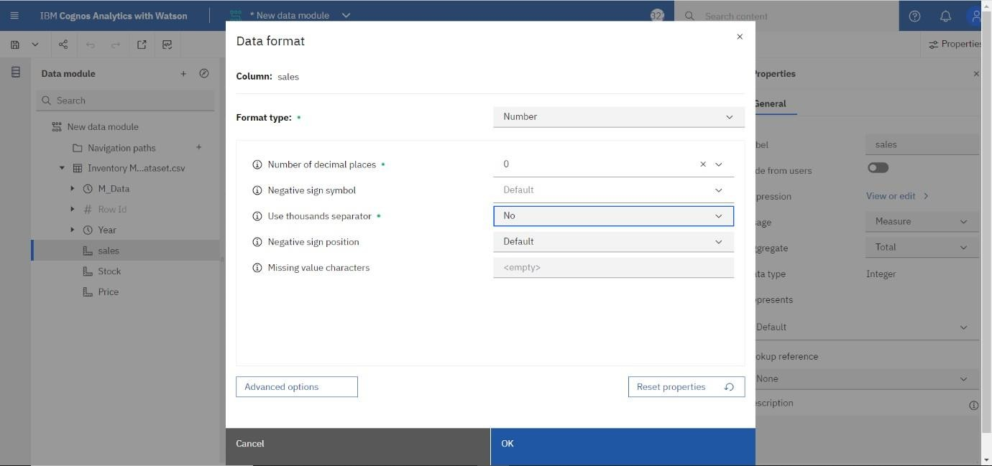

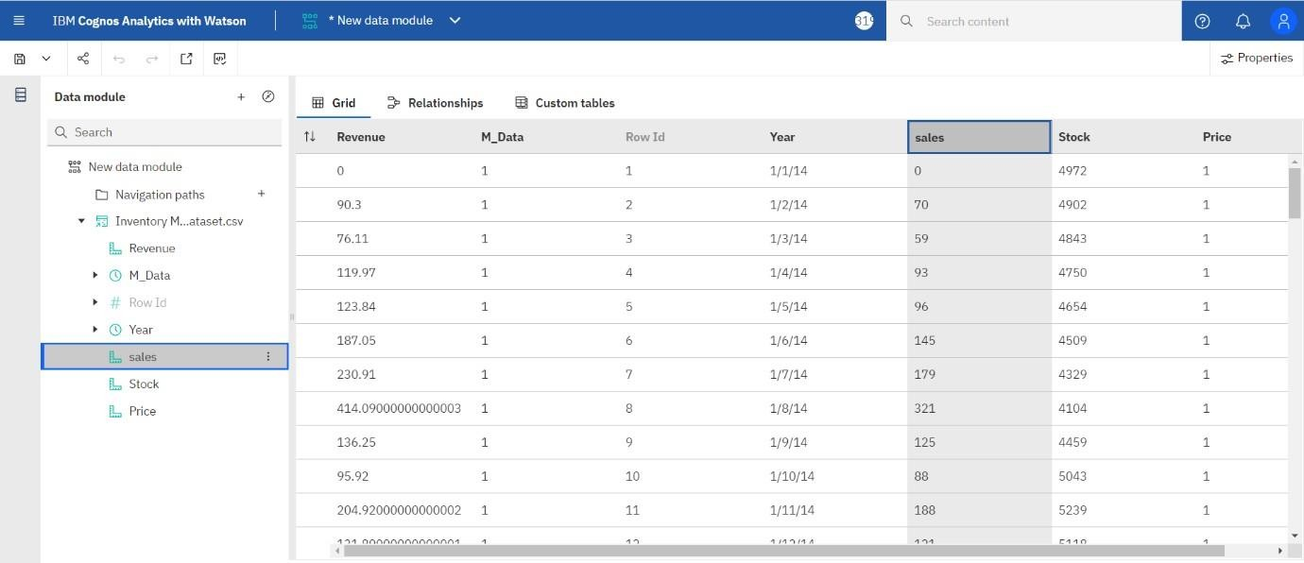

Price Format Data:

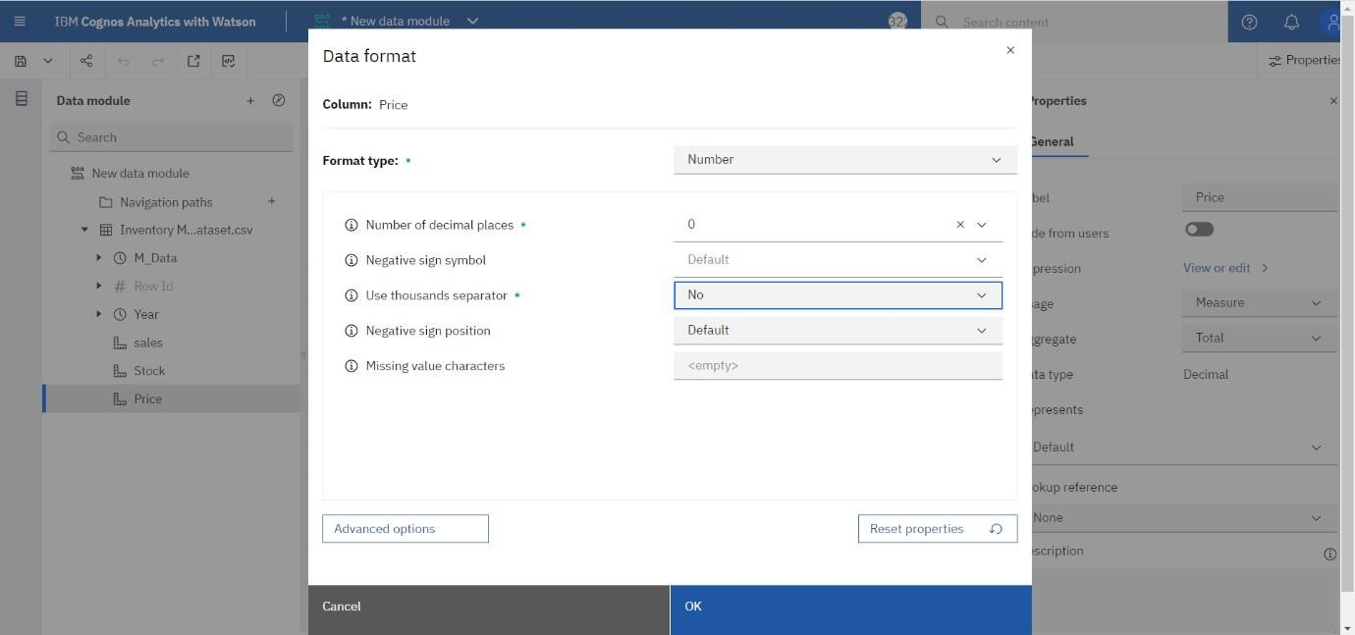

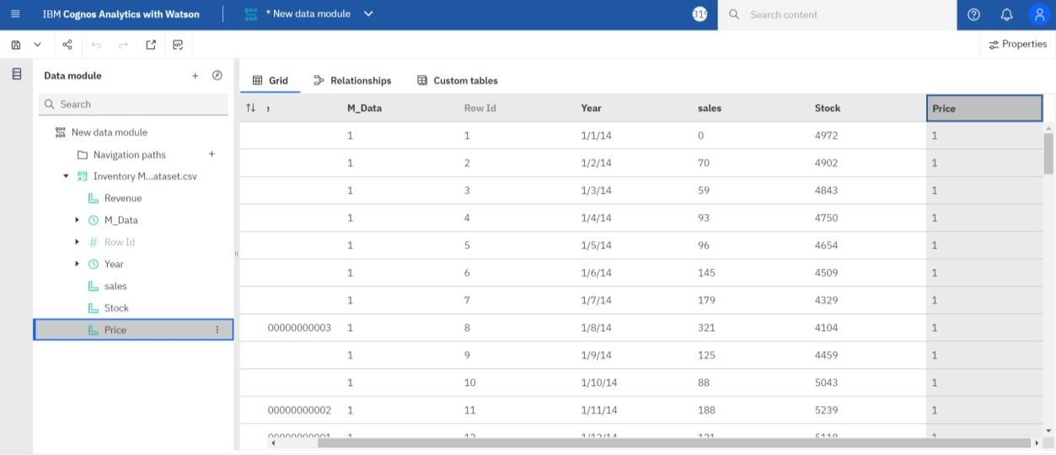

Revenue Format Data:

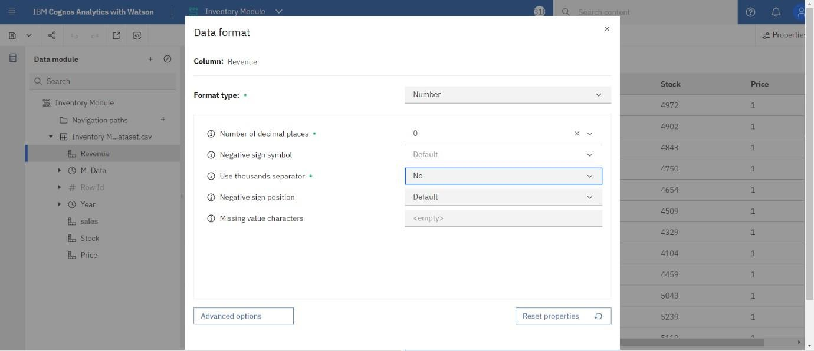

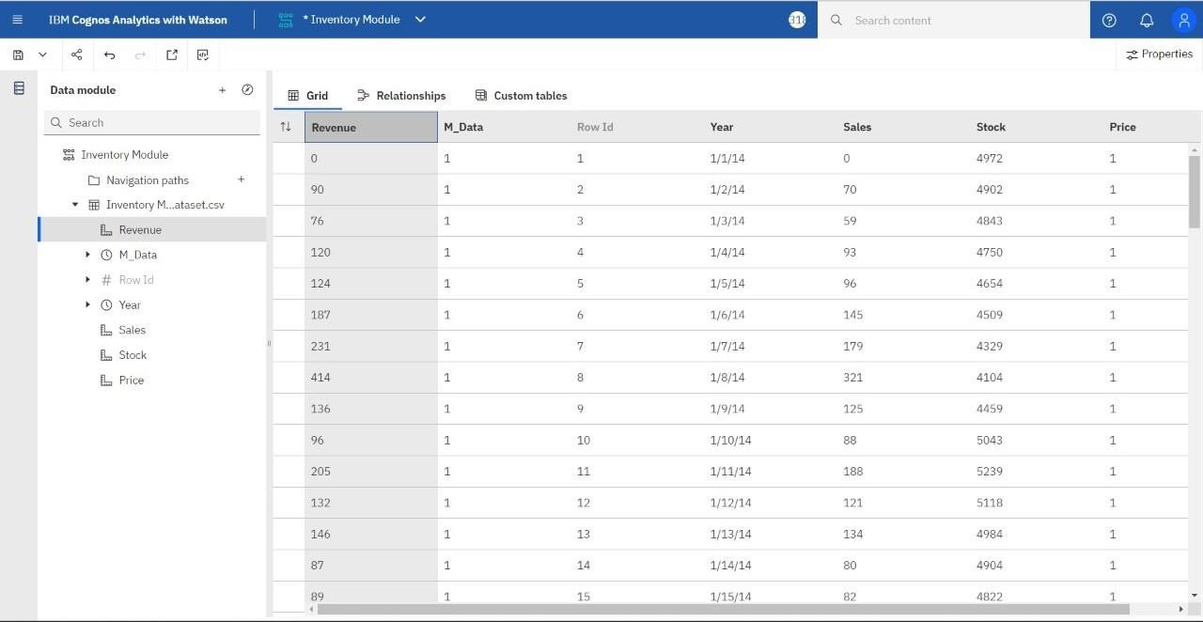

Year Properties:

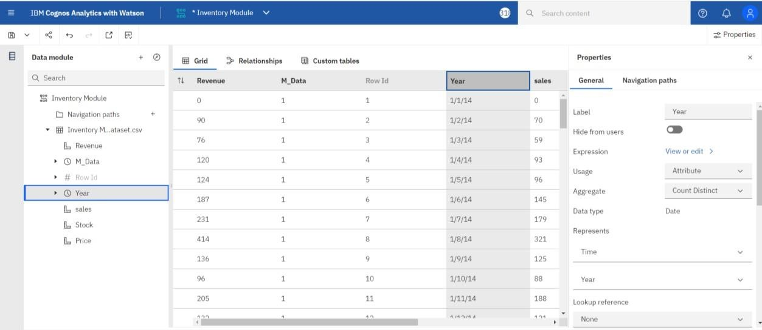

Sales Properties:

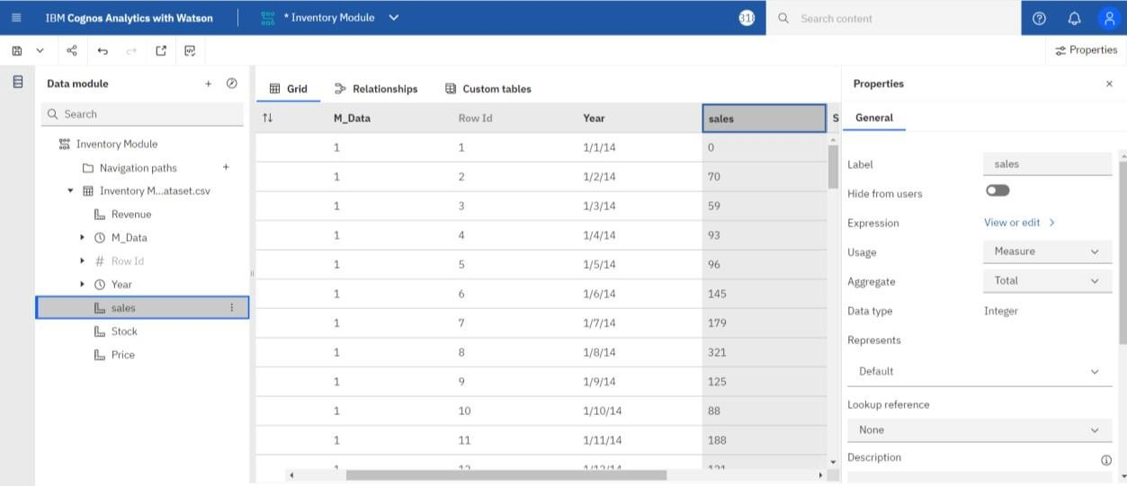

Stock Properties:

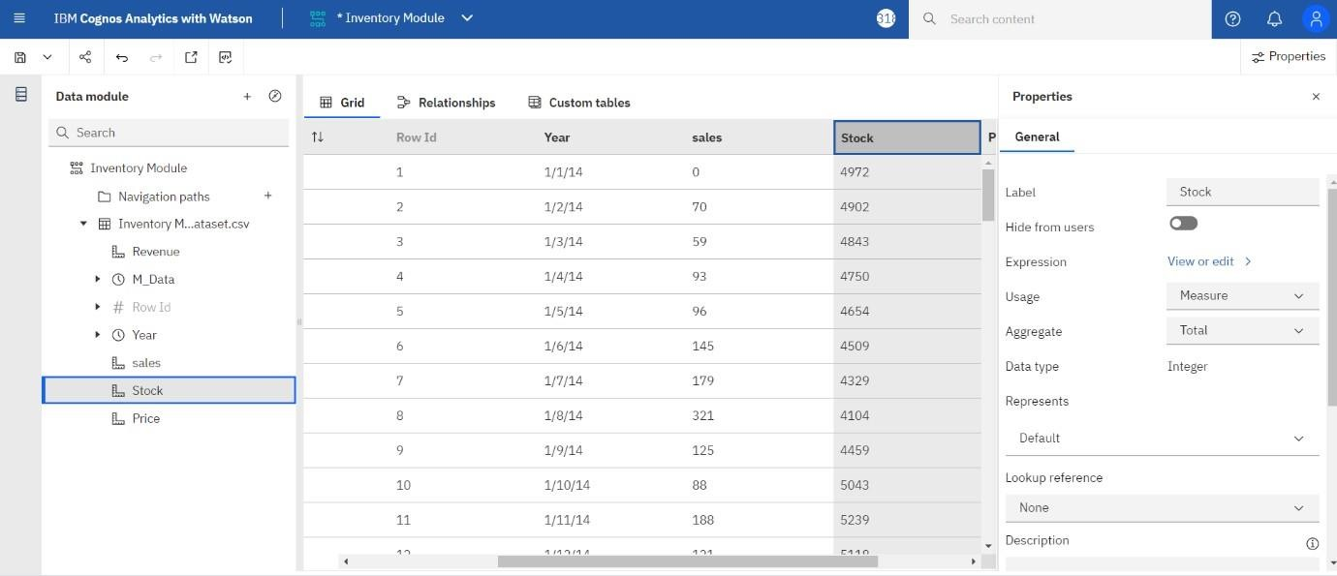

Price Properties:

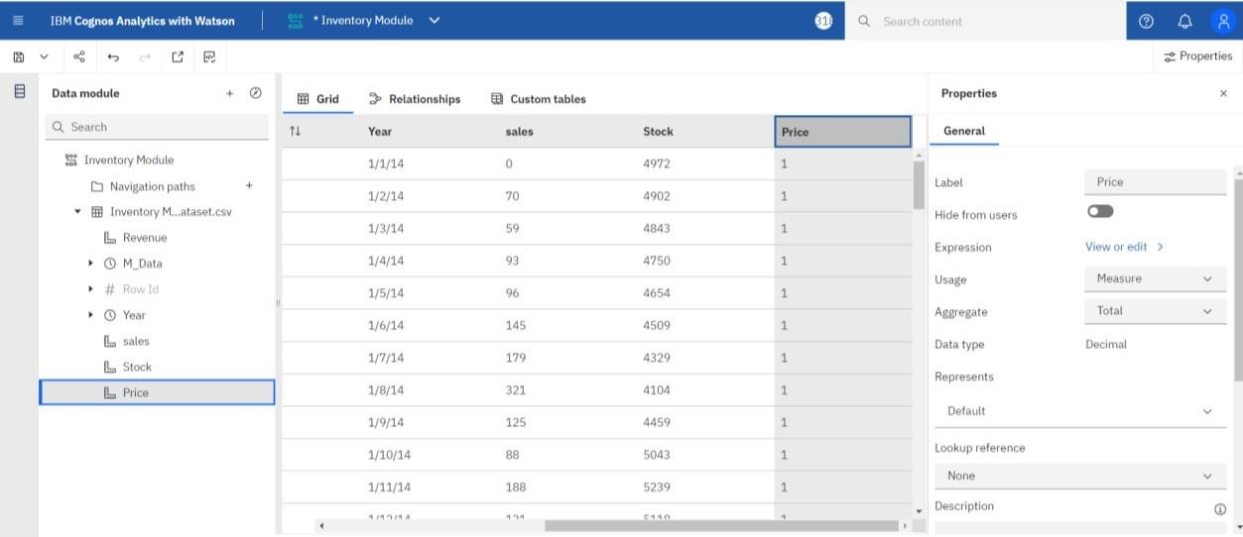

Revenue Properties:

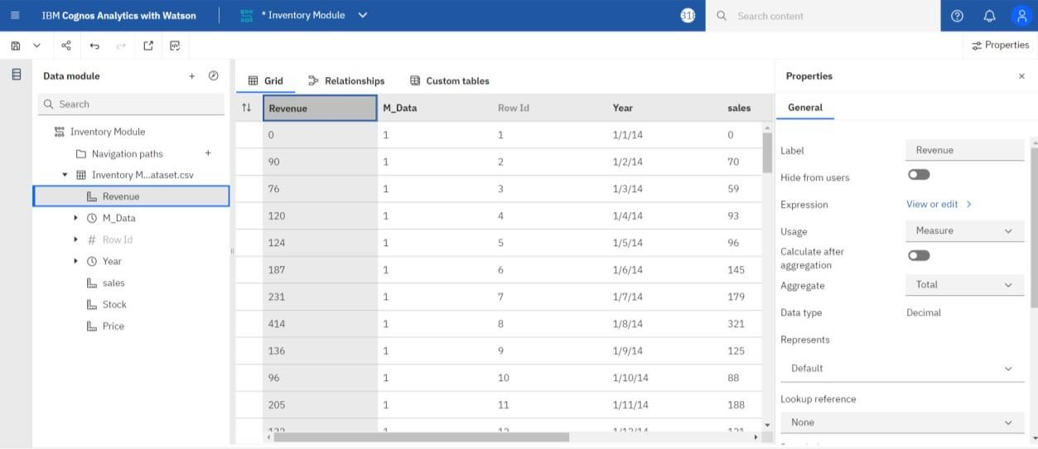

M_Data Properties:

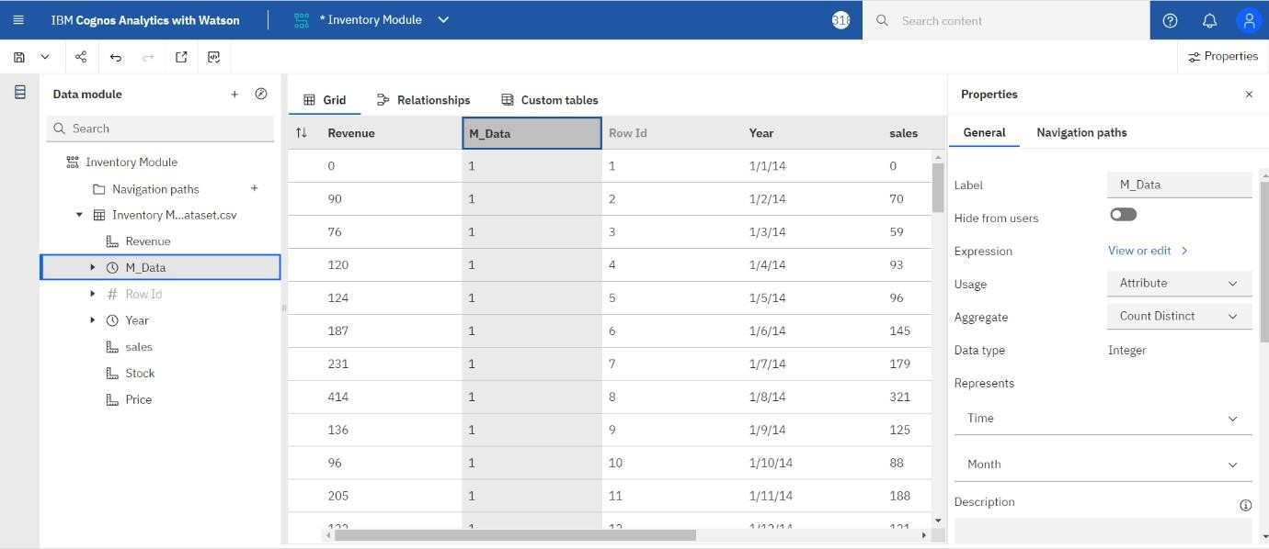

Prepared Data link:

https://us3.ca.analytics.ibm.com/bi/?perspective=ca- modeller&pathRef=.my_folders%2FInventory%2BModule